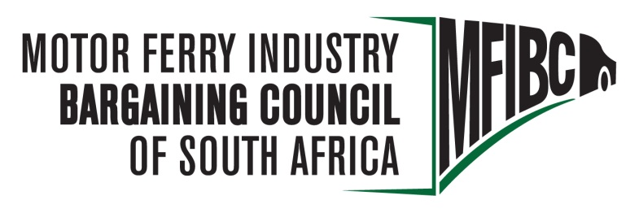
Regus Office Park, West Tower
2nd Floor, Nelson Mandela Square, Sandton
T: 011 881 5600
F: 011 881 5611
Email:jgyoung493@gmail.com
Website www.mfibc.co.za

MOTOR
MOTOR FERRY INDUSTRY BARGAINING COUNCIL OF SOUTH AFRICA

25 October 2018

Dear Sirs

NOTICE OF WAGE NEGOTIATION MEETING OF MFIBC

Kindly take note that a wage negotiation meeting of the Motor Ferry Industry Bargaining Council will take place on 20 and 21 November 2018 at OR Tambo International Garden Court 09h00.

The union delegates have been booked into the OR Tambo International Garden Court hotel for 19 and 20 November 2018.

The proposed agenda for the meeting is the following:

- Welcome
- Apologies
- Credentials
- Adoption of agenda
- Adoption of previous minutes
- Matters arising
- Wage negotiations
- Closure

If there are any queries, please do not hesitate to contact me on (061) 119 6259 or jgyoung493@gmail.com.

Yours faithfully

…………………….
J G YOUNG
SECRETARY
MOTOR FERRY INDUSTRY BARGAINING COUNCIL
061 119 6259
jgyoung493@gmail.com

